Горизонтальная линия

Bookstore website

**26 april 2020 Saparov Almas Serik Sanzhar Esengaliev Arsen Uralsk 2020-2021**

# About Project

In this project we created website for online bookstore. This website include:

* Catalog
* Authorization pages
* Page to order book
* Page to add book

# Technical information

* 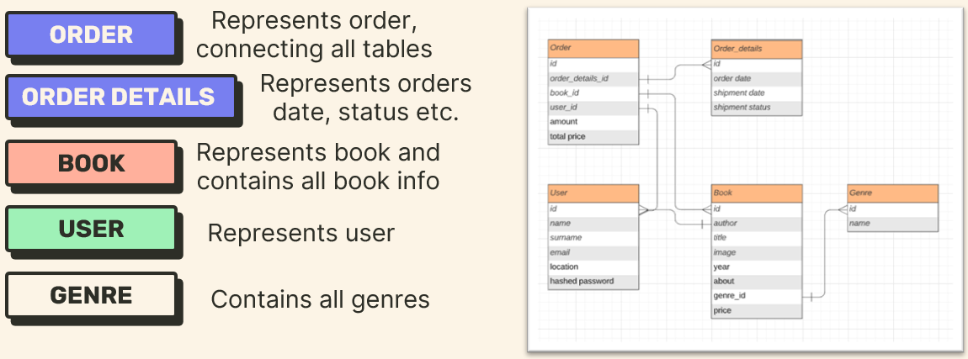Database
* Frontend

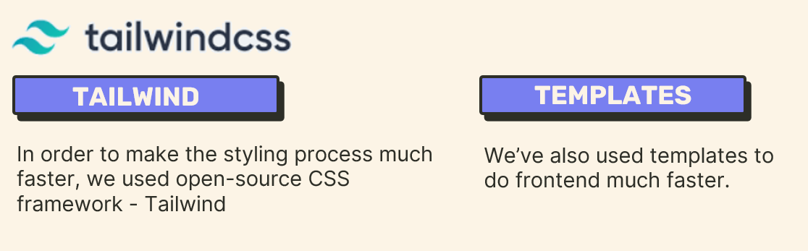

Used modules:

* Flask
* flask-upoads,
* wtforms
* sqlalchemy
* sys
* os